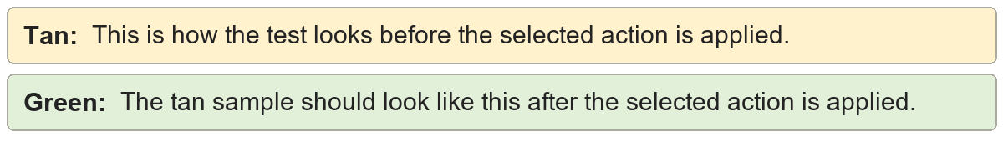
Consecutive section breaks | Shared section boundary sample.

Consecutive section breaks | Shared section boundary sample.

Next Page conversion | Shared section conversion sample.
Next Page conversion | Shared section conversion sample.

Continuous conversion | Shared section conversion sample.
Continuous conversion | Shared section conversion sample.

Even Page conversion | Shared section conversion sample.
Even Page conversion | Shared section conversion sample.

Odd Page conversion | Shared section conversion sample.
Odd Page conversion | Shared section conversion sample.

Consecutive page breaks | Shared manual page break sample.
Consecutive page breaks | Shared manual page break sample.

